Print Hello World

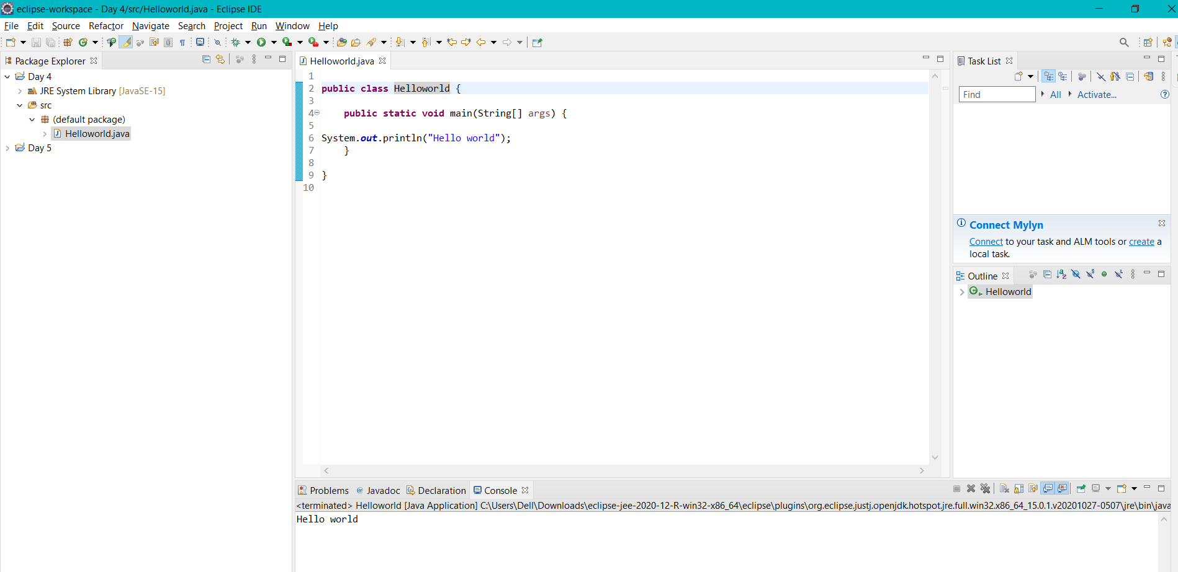

Add two numbers/binary numbers/characters

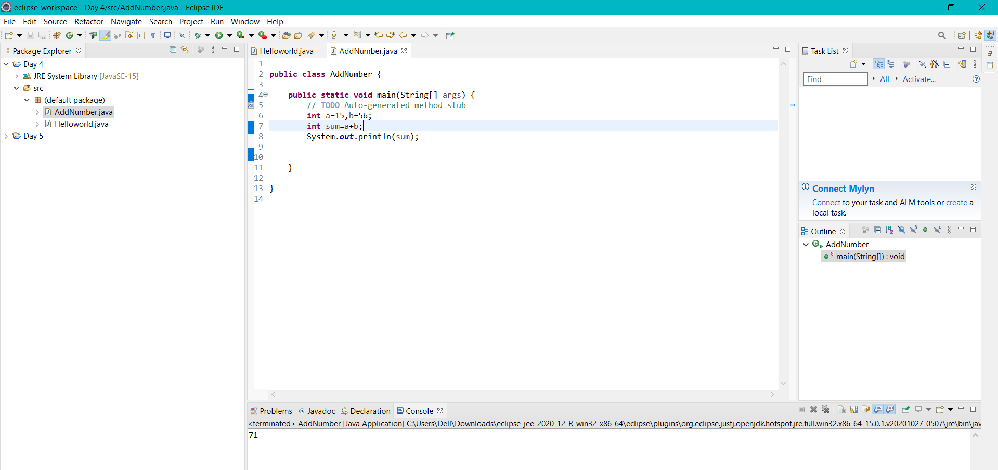

Calculate compound interest

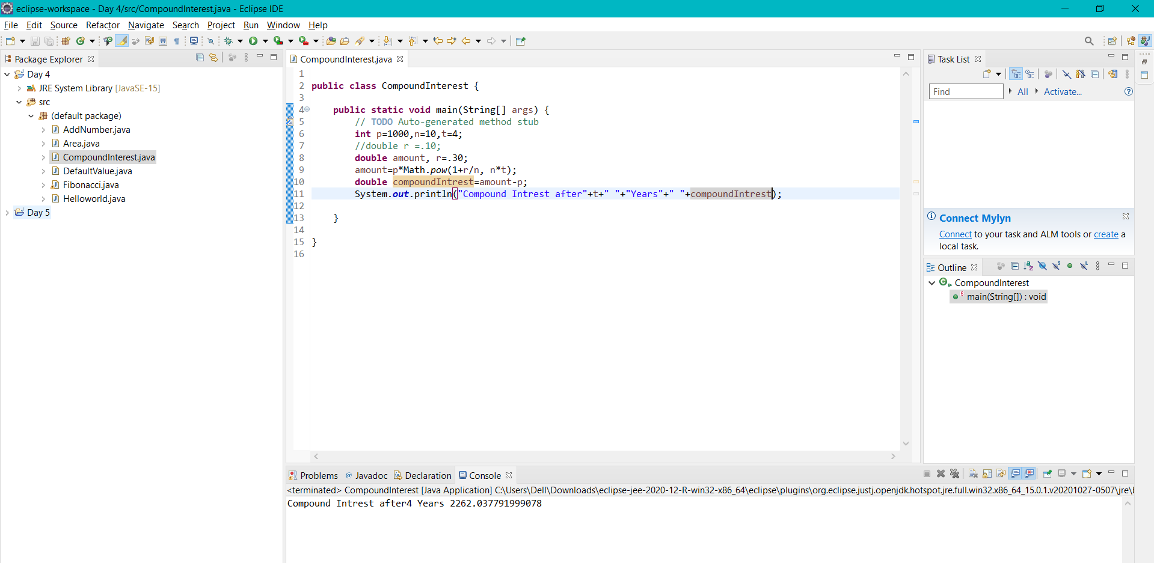

Calculate the area of rectangle Calculate area and circumference of a circle using multiple classes Java program

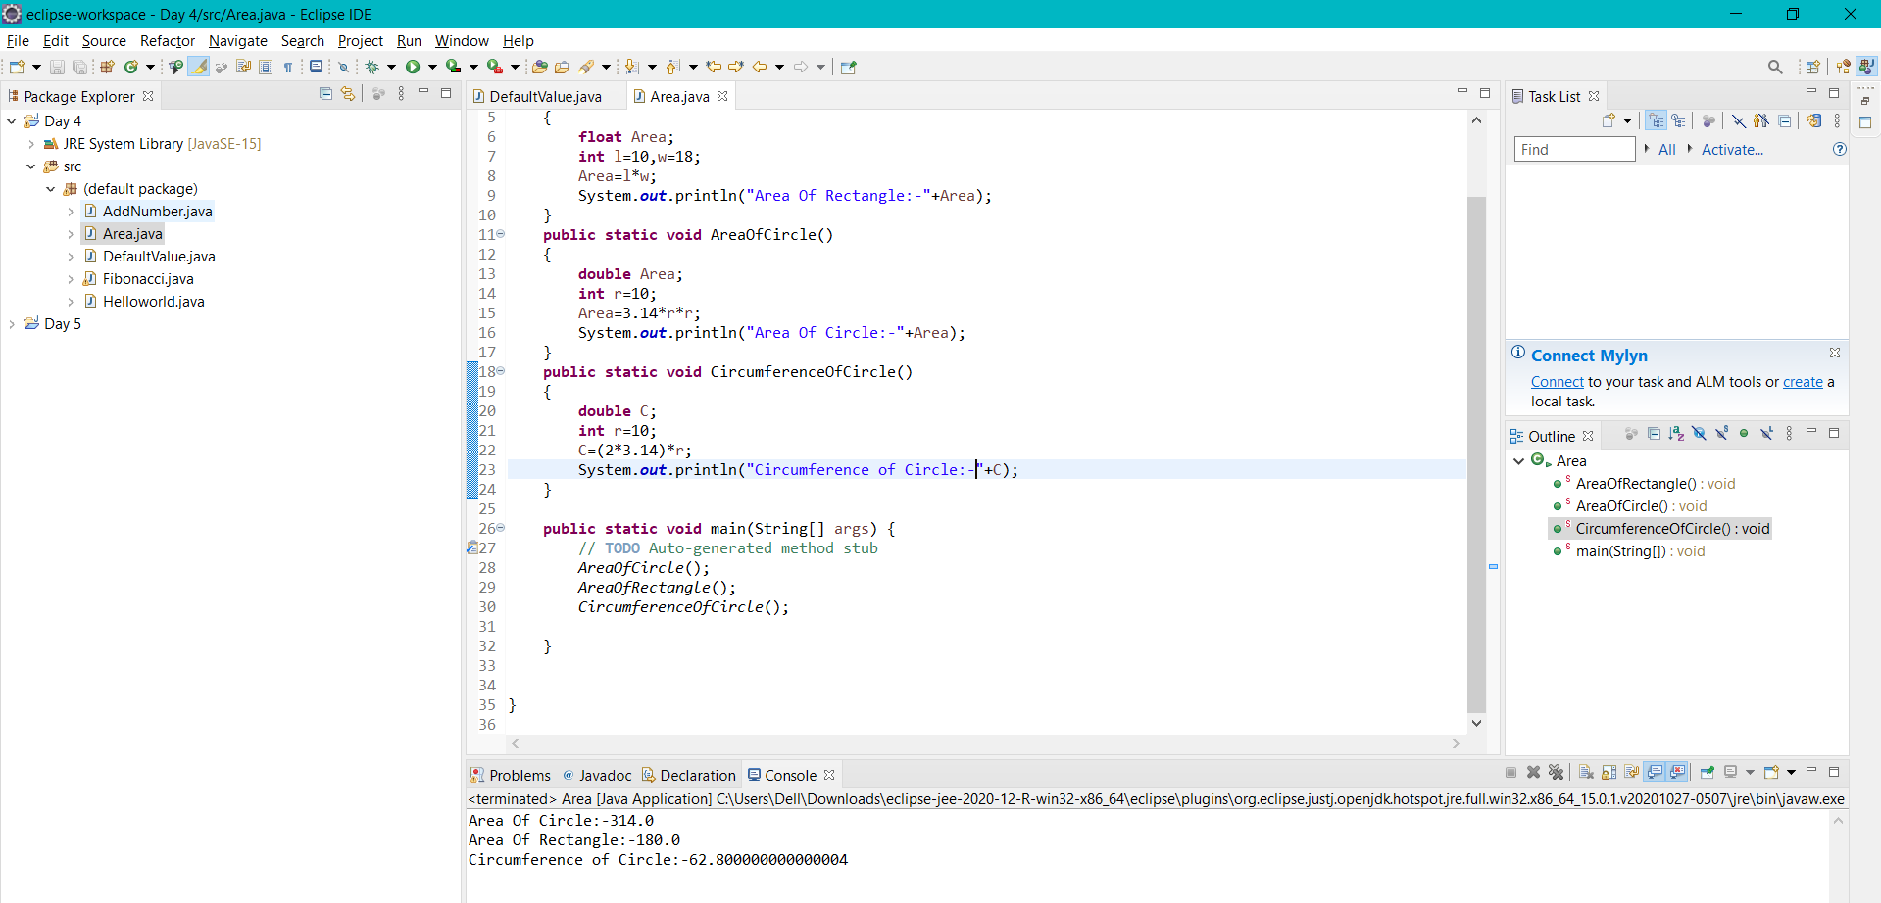

Print default values of primitive data type variable

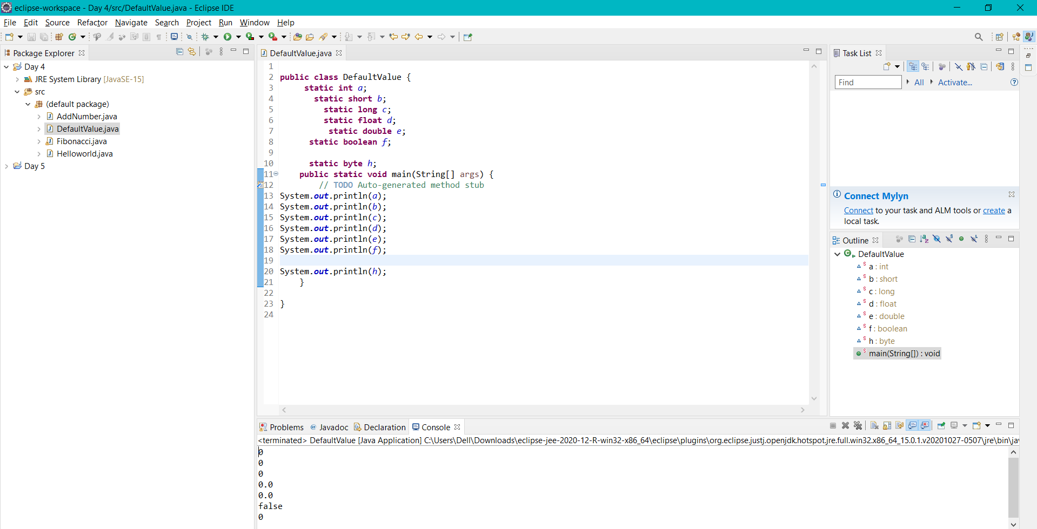

Print Fibonacci series till n

